**PROJECT REPORT**

**On**

**“ROADRASH-3”**

Submitted in

Partial Fulfillment of the Requirements for **MCA I Yr.**



**Session: 2021-2023**

**Submitted To**: **Submitted By**:

MR. Harshit Sharma Prakhar Saxena

Asst. Professor. Regn. No.21MCAN105

**DEPARTMENT OF IT & CA**

**JECRC UNIVERSITY**

**JAIPUR**

**DECLARATION**

I hereby declare that this project work entitled “ROADRASH-3” has been prepared by me during the year 2022 under the guidance of MR. HARSHIT SHARMA, Department of Computer Application and Information Technology, JECRC University Jaipur, in the partial fulfillment of MCA degree prescribed by the university.

I also declare that this project is the outcome of my own effort, that it has not been submitted to any other university for the award of any degree.

**TABLE OF CONTENTS**

1. INTRODUCTION
2. SYSTEM REQUIREMENT ANALYSIS

1. SYSTEM DESIGN
2. TECHNOLOGY USED
3. CODING
4. SCREEN SHOTS
5. CONCLUSION
6. BIBLOGRAPHY

**INTRODUCTION**

**RoadRash-3** is a unity engine based 3D game which is developed using unity tools. This is racing game where we can steer the car and race another AI based car.

**RoadRash-3** contains a grass terrain with blowing wind, trees, grass, fench, road .

The cars are using the C# based script which is used to control the movement and steering mechanics.

The AI is also using C# script and circuit of way points which are used for controlling the AI.

The assets are downloaded from unity itself and these high quality assets are used in creation of this game.

**SYSTEM REQUIREMENT ANALYSIS**

**Operating System :- WINDOWS 7, 8, 9, 10, 11**

**RAM :- 2 Gigabyte**

**ROM :- 50 Gigabyte**

**Graphics:- nVIDIA 1030 and above**

**Processor:- Intel i3 8th gen and above**

**Pixel Shader :- 2.0 and above**

**Keyboard**

**SYSTEM DESIGN**

**Unity Assets Store:-** *The Asset Store is home to thousands of free or affordably priced assets that save critical time and effort for Unity creators. In this guide, we’ll explain what each asset is, help you navigate the store and show you how to download and install the assets into Unity.*

The Unity Asset Store is a growing library of Assets. Both Unity Technologies and members of the community create these Assets and publish them to the store. There are various types of Assets in the store ranging from textures, animations and models to entire Project examples, tutorials and Editor extensions. There is a mix of free and affordable commercial Assets that you can download directly into your Unity Project. You can become a publisher on the Asset store and sell your Unity creations.

You can visit the Unity Asset Store in a couple of ways: either visit the [website](https://assetstore.unity.com/), or through the Unity Game Engine. To access the store via the Game Engine, open your Project and go to **Window > Asset Store**.

**Note:** It is faster and easier to download and import assets through the Unity Engine. However, there are more assets available on the website version.

A Unity asset is an item that you can use in your game or Project. An asset may come from a file created outside of Unity, such as a 3D model, an audio file, an image, or any of the other types of file that Unity supports. There are also some asset types that you can create within Unity, such as an Animator Controller, an Audio Mixer or a Render Texture.

The Asset store is sorted into the different types of assets available. Here’s a breakdown of what each asset type is:

**3D assets**

The [3D assets](https://assetstore.unity.com/categories/3d) section includes vehicles, characters, props, vegetation and animations. Unity’s [humanoid animation retargeting](https://docs.unity3d.com/Manual/Retargeting.html) means you can mix and match characters and animations from various sources.

**Top rated 3d assets:**

1. [Nature Starter Kit 2](https://assetstore.unity.com/packages/3d/environments/nature-starter-kit-2-52977) contains trees and bushes compatible with the built-in tree generator, so you can easily create all kinds of new variations of your own. Edit the shapes and colors of the plants right inside Unity!

2. [Simple Town - Cartoon Assets](https://assetstore.unity.com/packages/3d/environments/urban/simple-town-cartoon-assets-43500) is a collection of content that’s suitable for nearly every purpose imaginable. It's everything you need to prototype, and can be used for any type of game genre.

3. [FPS Weapons](https://assetstore.unity.com/packages/3d/props/guns/fps-weapons-46108) is a high quality collection of animated first person weapons. There are over 34 weapon types to choose from, each with fire, reload, hide and ready animations, plus matching sound effects. It also includes two characters with 3rd person animations, and a simple demo scene is set up to test the weapons out of the box.

## 2D assets

The [2D assets](https://assetstore.unity.com/categories/2d) section includes sprites, textures, characters, environments, fonts, materials and UI elements.

**Top rated 2d assets:**

1. [Skybox Volume 2 (Nebula)](https://assetstore.unity.com/packages/2d/textures-materials/sky/skybox-volume-2-nebula-3392) is a package of various high quality, beautiful nebulae of different colors and planets that’s perfect for any space genre project.

2. [Mighty Heroes (Rogue) 2D Fantasy Characters Pack](https://assetstore.unity.com/packages/2d/characters/mighty-heroes-rogue-2d-fantasy-characters-pack-85770) is a project containing 6 characters with Unity animations. And lots of clothes and weapons for customization and creation of new characters.

3. [2D Forest Pack](https://assetstore.unity.com/packages/2d/environments/2d-forest-pack-41171) is a high quality, beautiful forest scene that comes with 120 recomposable sprites, 37 prefabs, 4 particle presets and a demo scene. This asset will make your scenes look amazing.

## Add-ons

[Adds-ons](https://assetstore.unity.com/categories/add-ons) are more advanced features you can import into your Project. Browse here for features such as Unity Ads, analytics, and in-app purchases.

## Audio

Sound design is an important component to create an immersive and emotionally-charged game experience. Finding the perfect music to go with your game isn’t easy, but you don’t have to make it from scratch. [Audio](https://assetstore.unity.com/categories/audio) has a library of sound files that you can use to enrich the user experience of your project.

The Unity Asset Store has a variety of free and affordable audio assets, including ambient, music, and sound effects, so it’s easy to find exactly what you’re looking for.

**Top rated audio:**

1. [Casual Game SFX Pack](https://assetstore.unity.com/packages/audio/sound-fx/free-casual-game-sfx-pack-54116) is a collection of free, original hand-crafted one-shot sound effects. It contains essential audio material covering most events of any casual game, from short blips for bonuses, juicy explosion sounds, tight snappy clicks for tile removal, ticking clocks for depicting the level running out of time, etc.

2. [Universal Sound FX](https://assetstore.unity.com/packages/audio/sound-fx/universal-sound-fx-17256) has over 5,000 sound effects you can use across any game genre.

3. [Absolutely Free Music](https://assetstore.unity.com/packages/audio/music/absolutely-free-music-4883) is a free collection of music in a variety of styles that you can use in all your projects. The package contains anything from trance, orchestral, instrumental, rock, symphorock, etc.

## Templates

The [Templates](https://assetstore.unity.com/categories/templates) section allows you to download various tutorials and starter packs, a great section especially for beginners.

**Top rated templates:**

1. [Tanks Multiplayer](https://assetstore.unity.com/packages/templates/tutorials/tanks-multiplayer-69172) is an action packed multiplayer template running on Unity Networking or Photon Unity Networking. Play in one of four different teams with up to 12 players per room and compete for the highest team deathmatch score.

2. [Corgi Engine - 2D + 2.5D Platformer](https://assetstore.unity.com/packages/templates/systems/corgi-engine-2d-2-5d-platformer-26617) is a complete platformer solution for Unity. It's a tight character controller for your game. It's very fast and works on desktop, mobile, and anywhere you want. This is the perfect asset to create the 2D + 2.5D platformer or run & gun game you want!

3. [Top Down 2D RPG Kit](https://assetstore.unity.com/packages/templates/packs/top-down-2d-rpg-kit-starter-version-43566) lets you create your own top down 2D RPG with 100+ well documented, modular and fully customizable scripts.

## Tools

Browse here for [useful tools](https://assetstore.unity.com/categories/tools) to help you create your project. There is a wide spectrum of options for your project needs, anything from [AI](https://assetstore.unity.com/categories/tools/ai) to [Visual Scripting](https://assetstore.unity.com/categories/tools/visual-scripting).

**Top rated tools:**

1. [GAIA](https://assetstore.unity.com/packages/tools/terrain/gaia-42618) is an all in one terrain and scene generation system for both artists and programmers. This 5-star tool allows you to easily create environments in minutes by stamping textures, mountains, rivers, trees, buildings and props, skies and lighting.

2. [Final IK](https://assetstore.unity.com/packages/tools/animation/final-ik-14290) is a collection of Inverse Kinematics solutions which help provide beautiful motion for both humanoid and non-humanoid models in your projects.

3. [Easy Roads 3D](https://assetstore.unity.com/packages/tools/terrain/easyroads3d-pro-v3-469) is a powerful road terrain generator which lets you create unique road networks directly in Unity based on your own models.

## VFX

Visually enhance your Unity project with [visual effects](https://assetstore.unity.com/categories/vfx). These include particle effects and shaders.

**Top rated VFX assets:**

1. [Unity Particle Pack](https://assetstore.unity.com/packages/essentials/asset-packs/unity-particle-pack-73777) is a set of sample particle assets to use in your games, and to help you understand how to achieve certain effects using the Unity Particle System component and modules.

2. [Post Processing Stack](https://assetstore.unity.com/packages/essentials/post-processing-stack-83912) is an über effect that combines a complete set of image effects into a single post-process pipeline.

3. [Realistic Effects Pack 4](https://assetstore.unity.com/packages/vfx/particles/spells/realistic-effects-pack-4-85675) provides a diverse array of spectacular particle effects to bring your project to life.

## Navigating the Unity Asset Store

You can access the Unity Asset Store through the [website](https://assetstore.unity.com/) or the Unity Game Engine. To access in the Unity Game Engine, open your Project in Unity and go to **Window > Asset Store**. This opens a new tab in the Editor.

**Unity Pre-sets :-** Presets are assets that you can use to save and apply identical property settings across multiple components, assets, or [Project Settings](https://docs.unity3d.com/Manual/comp-ManagerGroup.html) windows. You can also use Presets to specify default settings for new components and default [import settings](https://docs.unity3d.com/Manual/ImportingAssets.html) for assets in the [Preset Manager](https://docs.unity3d.com/Manual/class-PresetManager.html) The Preset Manager supports any importers, components, or scriptable objects you add to the Unity Editor.

You can only apply Presets in the Editor. Presets have no effect at runtime. You can use scripting to [support presets](https://docs.unity3d.com/Manual/SupportingPresets.html) in your own Monobehaviour, ScriptableObject or ScriptedImporter classes.

## Saving and applying Presets

Presets allow you to save the property configuration of a component, asset, or Project Settings window as a Preset asset. You can then use this Preset asset to apply the same settings to a different component, asset, or Project Settings window.

For example, you could edit the properties of a **Rigidbody**  
 component, save these settings to a Preset asset, then apply that Preset asset to Rigidbody components in other **GameObjects**  
. The other components in the GameObjects are not affected; the Preset only applies its settings to the Rigidbody component.

You can store Presets in the Assets folder of your project. Use the [Project](https://docs.unity3d.com/Manual/ProjectView.html) window to view and select Presets to edit in the **Inspector**  
.

To save property settings to a Preset asset, follow the instructions below. You can save property settings while in Edit mode or in Play mode.

1. Select the GameObject, Asset import settings, or Project Settings window from which you want to reuse settings. When you select it, it appears in the **Inspector** window.
2. In the **Inspector** window, configure the properties as you want to save them.
3. Click the Preset selector (the slider icon) at the top-right of the **Inspector** window.
4. In the Select Preset window, click **Save current to**.
5. Choose the location of your new Preset, enter its name, and click **Save**.

## Applying settings from a Preset

There are two ways to apply a Preset: the **Select Preset** window, or for component Presets, you can also drag and drop a Preset from the **Project**  
 window onto the GameObject that contains that component.

**Note:** Applying a Preset copies properties from the Preset to the item. It doesn’t link the Preset to the item. Changes you make to the Preset do not affect the items you have previously applied the Preset to.

To apply a Preset via the **Select Preset** window:

1. For GameObjects or assets you want to apply a Preset to, select them so that they appear in the **Inspector** window. For Project Settings that you want to apply a Preset to, open them in the **Project Settings**  
    window.
2. In the **Inspector**, click the Preset selector (the slider icon).
3. In the **Select Preset** window, search for and select the Preset to apply.

Unity applies this Preset to the component, asset, or Project Settings window.

1. Close the **Select Preset** window.

If you apply a component Preset via drag-and-drop, Unity’s behavior depends on the state of your GameObject:

* If you drop the Preset on an existing GameObject in the Hierarchy window, Unity adds a new component and copies properties from the Preset.
* If you drop the Preset on an empty area in the Hierarchy window, Unity creates a new, empty GameObject and adds a component with properties copied from the Preset.
* If you drop the Preset on the Inspector window onto the title of an existing component, Unity copies properties from the Preset.
* If you drop the Preset on an empty area in the Inspector window, Unity adds a new component and copies properties from the Preset.

### Applying partial Presets

You can choose to only apply some properties from a Preset and exclude others. To do this:

1. Select your Preset in the **Project** window.
2. In the **Inspector**, right-click a property and choose **Exclude Property**. The window displays a red horizontal line next to e xcluded properties.
3. Apply the Preset to the target component, asset, or Project settings.

**Note:** To select all or clear all checkboxes in a Preset, select the **More items** menu (**⋮**) or right-click the Preset name, and select **Include all properties** or **Exclude all properties**. You can still adjust individual properties if you need to.

You can also use the Exclude option for Presets that you then set as the default configuration for components and asset importers. See [Preset Manager](https://docs.unity3d.com/Manual/class-PresetManager.html) for more details on how to do this.

## Editing a Preset

To edit a Preset asset, select it from the **Project** window and view it in the **Inspector** window.

**Note:** When you change the properties in a Preset, your changes do not affect items you have already applied the Preset to. For example, if you apply a Preset for a Rigidbody component to a GameObject, and then edit the Preset, the settings in the Rigidbody component do not change.

## Importing Assets using Presets by folder

You can use a [script](https://docs.unity3d.com/Manual/DefaultPresetsByFolder.html) to apply a Preset to an Asset based on the location of the Asset in the Project window.

## Exporting Preset Assets

Use Presets to streamline your team’s workflows. You can even use Presets to specify settings for [Project Settings](https://docs.unity3d.com/Manual/comp-ManagerGroup.html) windows, including the **Preset** settings themselves. Use this feature to configure a project then [export it](https://docs.unity3d.com/Manual/AssetPackagesCreate.html) as a custom **asset package**  
. Your team members can [import](https://docs.unity3d.com/Manual/AssetPackagesImport.html) this asset package into their projects.

1. In the **Project window**  
   , select the Presets you want to export .
2. In the Unity menu, go to **Assets > Export Package**, or right-click inside the Project window and choose **Export Package**.  
   The **Exporting package** window displays the items to export.
3. If your Presets contain references to assets you want to include in the package, enable **Include dependencies**.
4. Click **Export**.
5. Choose where you want to store the package, enter a filename, and click **Save**. Unity saves the package as a .unitypackage file.

## Using Presets for transitions of Animation State nodes

You can save and apply Presets for [Animation State](https://docs.unity3d.com/Manual/class-State.html) nodes. However, the [transitions](https://docs.unity3d.com/Manual/class-Transition.html)  
 in the Preset are shared among Presets and the nodes that you apply the Preset to. For example, you apply a Preset to two different nodes in the [Animator window](https://docs.unity3d.com/Manual/AnimatorWindow.html)  
. In the Inspector window, you edit the settings for one of the transitions in the first node. Your change also appears in the other node and in the Preset.

**TECHNOLOGY USED**

* **Unity Engine**

Unity, founded and launched by Unity Technologies, is well-known as one of the high-end game engines. If you are a game developer, you can easily use it. Due to its alluring design, Unity has made a massive fan base responsible for the engine’s growth.

Unity comprises AR, VR, 2D, and 3D games tools that developers can deploy across multiple platforms, such as mobile devices, PCs, gaming consoles, and the web. Unity’s robust features help developers execute cinematic animations and photorealistic assets. Moreover, this game engine can now show life-like characters, captivating environments, and well-defined objects.

With Unity, developers don’t need to switch between platforms. After all, Unity gives the convenience of coding game commands also. In short, this game engine lets you create high-end and fast games.

Here is some statistical information about Unity:

* The top 34% of free mobile games available on the Play Store and App Store have used Unity Game Engine for development.
* Mobile games created with Unity justify [71% of the best 1000 titles](https://investors.unity.com/news/news-details/2021/Unity-Announces-Fourth-Quarter-and-Full-Year-2020-Financial-Results/default.aspx).
* There are [2.8 billion](https://create.unity.com/2021-game-report) monthly active users involved with content operated or made by Unity Game Engine in 2020.
* [5 Billion downloads](https://images.response.unity3d.com/Web/Unity/%7B4eb56531-e6aa-492f-8fda-c68ae20af950%7D_2021_Gaming_Report_-_Operate_Solutions.pdf) per month of applications developed using Unity.
* [94 out of the leading 100 development studios](https://images.response.unity3d.com/Web/Unity/%7B4eb56531-e6aa-492f-8fda-c68ae20af950%7D_2021_Gaming_Report_-_Operate_Solutions.pdf) by worldwide revenue are Unity clients.

# Overview of .NET in Unity

Unity uses the open-source .NET platform to ensure that applications you make with Unity can run on a wide variety of different hardware configurations. The .NET platform supports a range of languages and API libraries.

## Scripting backends

Unity has two scripting backends; Mono, and [IL2CPP](https://docs.unity3d.com/Manual/IL2CPP.html)  
 (Intermediate Language To C++), each of which uses a different compilation technique:

* Mono uses just-in-time (JIT) compilation and compiles code on demand at runtime.
* IL2CPP uses ahead-of-time (AOT) compilation and compiles your entire application before it runs.

The benefit of using a JIT-based scripting backend is that the compilation time is typically much faster than AOT.

By default, Unity uses the Mono backend on platforms that support Mono. When you build a player for your application, you can choose which scripting backend to use. To do this through the Editor, go to **Edit** > **Project Settings** > **Player**, open the **Other Settings** panel, then click on the **Scripting Backend** dropdown and select which backend you want. For more information, see [Scripting backends](https://docs.unity3d.com/Manual/scripting-backends.html)  
.

## Managed code stripping

When you build an application, Unity compiles and then searches the assemblies (.DLLs) in your project to detect and remove unused code. This process of stripping code reduces the final binary size of your build, but increases build time.

Code stripping is disabled by default when you use Mono but code stripping can’t be disabled for IL2CPP. You can control how much code Unity strips with the **Managed Stripping Level** property.

To change this property, go to **Edit** > **Project Settings** > **Player**, open the **Other Settings** panel, then click on the **Managed Stripping Level** dropdown and select a stripping level.

As you increase the **Managed Stripping Level**, Unity removes more code. This increases the risk that Unity might remove code that your application relies on, especially if you use reflection or generate code at runtime.

You can use annotations on certain elements of your code to prevent Unity from stripping it. For more information, see [Managed Code Stripping](https://docs.unity3d.com/Manual/ManagedCodeStripping.html).

## Garbage collection

Unity uses the [Boehm garbage collector](https://en.wikipedia.org/wiki/Boehm_garbage_collector) for both the Mono and IL2CPP backends. Unity uses the **Incremental** mode by default. You can disable the **Incremental** mode to use stop-the-world garbage collection, although Unity recommends the **Incremental** mode.

To toggle between Incremental mode and stop-the-world, go to **Edit** > **Project Settings** > **Player**, open the **Other Settings** panel and click on the **Use incremental GC** checkbox. In **Incremental** mode, Unity’s garbage collector only runs for a limited period of time and doesn’t necessarily collect all objects in one pass. This spreads the time it takes to collect objects over multiple frames and reduces stuttering and CPU spikes. For more information, see [Managed memory](https://docs.unity3d.com/Manual/performance-managed-memory.html).

To check the number of allocations and possible CPU spikes in your application, use the [Unity Profiler](https://docs.unity3d.com/Manual/Profiler.html). You can also use the [GarbageCollector](https://docs.unity3d.com/ScriptReference/Scripting.GarbageCollector.html) API to completely disable garbage collection in Players. When the collector is disabled, be careful to avoid allocating excess memory.

## .NET system libraries

Unity supports many platforms and might use different scripting backends depending on the platform. The .NET system libraries require platform-specific implementations to work correctly in some cases. While Unity tries its best to support as much of the .NET ecosystem as possible, there are some exceptions to parts of the .NET system libraries that Unity explicitly doesn’t support.

Unity makes no performance or allocation guarantees for the .NET system libraries across Unity versions. Generally, Unity doesn’t fix any performance regressions in the .NET system libraries.

Unity doesn’t support the System.Drawing library and it isn’t guaranteed to work on all platforms.

The JIT compilation that the Mono scripting backend uses enables you to emit dynamic C#/.NET Intermediate Language (IL) code generation during the runtime of your application. The **AOT compilation**  
 that the IL2CPP scripting backend uses doesn’t support dynamic code generation.

This is important to consider when you use third-party libraries, because they might have different code paths for JIT and AOT, or they might use code paths that rely on dynamically generated code. For more information on how to generate code at runtime, see Microsoft’s [ModuleBuilder](https://docs.microsoft.com/en-us/dotnet/api/system.reflection.emit.modulebuilder?view=netcore-3.1" \t "_blank) documentation.

Although Unity supports multiple .NET API profiles, you should use the .NET Standard [API Compatibility Level](https://docs.unity3d.com/ScriptReference/ApiCompatibilityLevel.html) for all new projects for the following reasons:

* .NET Standard is a smaller API surface and so has a smaller implementation. This reduces the size of your final executable file.
* .NET Standard has better cross-platform support, so your code is more likely to work across all platforms.
* All .NET runtimes support .NET Standard, so your code works across more VM/runtime environments (for example, .NET Framework. .NET Core, Xamarin, Unity) when you use .NET Standard.
* .NET Standard moves more errors to compile time. A number of APIs in .NET Framework are available at compile time, but have implementations on some platforms that throw an exception at runtime.

Other profiles can be useful if, for example, you need to provide support for an older existing application. To change the **Api Compatibility Level** setting, go to **Edit** > **Project Settings** > **Player**. Under the **Other Settings** heading, set the **Api Compatibility Level** to the desired setting.

For more information, see [.NET Profile Support](https://docs.unity3d.com/Manual/dotnetProfileSupport.html).

## Using third-party .NET libraries

You should only use third-party .NET libraries that have been extensively tested on a wide range of Unity configurations and platforms.

The performance characteristics of JIT and AOT code paths in third-party libraries might be significantly different. AOT generally reduces startup times and is suited to larger applications for this reason but increases the binary file size to accommodate the compiled code. AOT also takes longer to build during development.

JIT adjusts at runtime based on the platform it’s running on, which can increase running performance at the cost of a potentially longer application startup time. As such, you should profile your application in both the Editor, and on your target platform. For more information, see [Profiler overview](https://docs.unity3d.com/Manual/Profiler.html).

You should profile the usage of your .NET system libraries on all target platforms because their performance characteristics might vary depending on the scripting backends, .NET versions, and profiles you use.

When you review a third-party library, consider the following areas:

* Compatibility: Third-party libraries might not be compatible with some Unity platforms and scripting backends.
* Performance: Third-party libraries might have vastly different performance characteristics in Unity compared to other .NET runtimes.
* AOT binary size: Third-party libraries might increase AOT binary size significantly because of the number of **dependencies**  
   the library uses.

### Managed plug-in settings

Managed plug-ins can be third-party libraries or user-compiled assemblies that you want to include in the project.

### General - Auto Reference

The **Auto Reference** setting controls how assembly definitions in the project reference a plug-in file. When you enable Auto Reference, all predefined assemblies and assembly definitions automatically reference the plug-in file.

**Auto Reference** is enabled by default.

To limit the scope in which a plug-in can be referenced, disable Auto Reference. You then need to explicitly declare all references to that plug-in. You might want to do this if:

* You want to prevent **scripts**  
   from mistakenly using the plug-in.
* You are iterating on the plug-in and want to reduce compilation time. If you explicitly declare a plug-in, Unity recompiles only the dependent assemblies, not your entire project.
* You want to prevent plug-ins used in an [Asset Store package](https://docs.unity3d.com/Manual/AssetStorePackages.html) from conflicting with other code in a project into which the package is imported.

When you disable **Auto Reference** Unity cannot reference a plug-in from the predefined assemblies it creates for your project. These predefined assemblies contain all the scripts in your project that you have not assigned to another assembly using an assembly definition file. To reference classes, functions, or other resources from a plug-in that has the **Auto Reference** property disabled, the referencing code must be in an assembly created with an assembly definition file. For example, if a set of scripts in your project uses a plug-in, you must create an assembly definition file for those scripts, and add an explicit reference to the plug-in in the definition file.

More than one assembly can use the plug-in, but all assemblies must explicitly declare the dependency. To learn more about assembly definitions in Unity, see [Assembly definitions](https://docs.unity3d.com/Manual/ScriptCompilationAssemblyDefinitionFiles.html).

**Note**: The **Auto Reference** option has no effect on whether a file is included in the build. To control Build Settings for plug-ins use [Platform settings](https://docs.unity3d.com/Manual/PluginInspector.html#platform).

### General - Validate References

Unity can check that your plug-in’s references are available in the project. If you don’t perform this validation, users can encounter runtime errors when the application tries to use a missing reference.

Enable the **Validate References** option to check:

* Whether the plug-in’s references exist. For example, if your plug-in references the plug-in Newtonsoft.Json.dll, and Unity cannot find Newtonsoft.Json.dll, Unity displays an error.
* Whether strong named references will be able to load. This is important because strong named references need to match the version. For example, if you compile a plug-in with a reference to “b.dll” version 2.0.0, that version must be in the project.

If you don’t want to check strong named references, but still want to check that references exist:

1. In the **Plugin** inspector, enable **Validate References**.
2. In **Project Settings** > **Player** > **Other Settings** > disable **Assembly Version Validation**.

### Define Constraints

You can specify conditions under which Unity loads the plug-in to memory and references it. These conditions are symbols that must be satisfied, which means either defined or undefined.

Constraints work like the #if preprocessor directive in C#, but on the assembly level instead of the script level. You can learn more about constraints in [Assembly Definition properties](https://docs.unity3d.com/Manual/class-AssemblyDefinitionImporter.html).

You can use any of Unity’s built-in define symbols, or add symbols in **Project Settings** > **Player** > **Other Settings** > **Script Compilation** > **Scripting Define Symbols**. The symbols you add are platform-specific, so you need to define them for each relevant platform. See [Platform dependent compilation](https://docs.unity3d.com/Manual/PlatformDependentCompilation.html) for more information, including a list of the built-in symbols.

**Tip**: To specify that a symbol must be undefined, prefix it with a negating ! (exclamation mark) symbol.

In the following example, we want Unity to load and reference the plug-in only on non-IL2CPP scripting runtimes for Unity 2018.3 or newer. We define two constraints, and both must be met:

* ENABLE\_IL2CPP is not defined
* UNITY\_2018\_3\_OR\_NEWER is defined

**Key Benefits of Using Unity for Game Development**

* To explain why Unity is well-known in the gaming industry, here are the key perks of this game engine discussed below:

**1. User Friendliness**

* Unity is more convenient to use as compared to other technologies. Other tricky technologies become more complex while used.

**2. Compatibility with Several Platforms**

* Unity has compatibility with multiple Operating Systems, such as Steam, iOS, PCs, Macs, Android, and consoles. Hence, using Unity, you can quickly build many games for different platforms and design multiple game stages.
* Every game stage has some vital elements, and Unity helps you shift them to the next phase and make the game more exceptional.

**3. Online Tutorials**

* The most convenient fact about Unity is that many training videos and tutorials are available online for every learner. You can even develop easy and small games with training using Unity.

**4. Availability of the Rich Asset Store**

* The Unity Asset Store provides [game developers](https://www.mindinventory.com/hire-game-developers.php) with its wide range of textures, pre-designed 3D models, unique animations, sounds, scripting languages, and object modeling, like a scenic backdrop, a popular character, a building, etc.
* Developers can easily purchase essential assets without making these on their own. The Unity asset store also provides the opportunity for musical artists, craftsmen or modelers to earn more money.

**5. Multiplayer Gaming**

* Some of the most popular miltiplayer games are made on the Unity engine. The platform offers many features that encourage developers to build high-end games for online players. Unity 3D makes the whole [game development process](https://www.mindinventory.com/blog/mobile-game-development-process/) fun and simple.

**6. 2D Game Development**

* Although Unity is primarily used for 3D game development, it includes features to create 2D games as well. The latest Unity version features the in-built 2D engine and rich assets to help developers build 2D games most conveniently.
* Moreover, this version allows developers to create 2D games for multiple devices, like gaming consoles, PCs, and mobiles.

**7. Community Assistance**

* Unity provides uninterrupted assistance from the team of developers. More than 2.5 million developers currently use Unity programming, and the number of users is increasing fast. The feasibility of sharing the client’s approval or disapproval with the development team is simple, and it can fix issues very quickly.

**8. Access to both Free and Pro Version**

* Unity is available in both free and pro versions with numerous features. You can select the free version and receive the highlights of the primary elements. Furthermore, you can use the pro version to build high-end games using features like feature playback, 3D composition booster, sound channel, etc.
* If you are a budding developer, you can use the free version and make your ideas come to life. But if you seek additional features, go for the pro-business plan.

**9. Top-Notch Graphics**

* Unity is famous for its next-level, top-notch graphics. The game engine provides highly customizable rendering technology and different engaging tools to aid superb-looking game development. In 3D games, developers can produce seamless, natural motions of objects also.

**10. Less Coding**

* You don’t need coding experience or knowledge to use the Unity game engine. Unity is feasible for beginners who want to start game development as a hobby or career. It uses Boo, JavaScript, and C#, but you can build a game without code writing.

**11. Debugging**

* Changing and debugging is simpler and more convenient with Unity. After all, you can see every game variable during gameplay. Unity is extraordinary because it helps developers debug the process at runtime.

**What are the Limitations of Unity Game Engine?**

* Apart from some unique perks, the Unity game engine has some limitations also. Let’s shed light on a few of them!

**1. No Link to External Code Libraries**

* Unity doesn’t support links to external code libraries. It is discouraging and unexpected for professional programmers. If you want to use a library, you must copy it manually into the project instead of just connecting to a shared folder.
* The inadequacy of one folder with libraries makes it hard to use the activities of various projects. And rationally, using version control systems overpower this inconvenience, but there is no instant fix to this issue in Unity.

**2. Expensive License**

* Developers must get licenses for the best functionality improvements, deployment, and graphics. These licenses are very costly.
* Furthermore, using stencil assistance, rendering, buffer support, and other features increases development expenses because of the expensive licenses.

**3. More Memory Consumption**

* Games built using the Unity engine consumes unnecessarily more memory. It ultimately makes debugging problems and OOM errors in the applications.

**4. Source Code**

* Unity features a search function to discover linked scripts; however, it could be unique. You often need to browse all elements manually in a scene to get related scripts. Nevertheless, you must avoid this time-consuming task.
* **How Can MindInventory Help you with Game Development?**
* At MindInventory, we specialise in [mobile game development](https://www.mindinventory.com/game-development-services.php) for a variety of industries using the Unity 3D platform. We have a team of professional graphic designers, developers, testers, and modelers who allow us to maximize our levels of expertise and skills in game development, artwork, level design, creative tasks, testing, and production.
* Are you planning to outsource Unity game development? There are many perks to derive from outsourcing Unity game development from a company like us. If you are a budding organization, the game app built by us can help your business grow. You don’t have to use up your resources or take risks for your business.
* It’s better to contact us as we have all the tools, experience, and expertise to carry out the task. We have been in the mobile game development sector for many years, and in these years, our organization has developed many games using Unity. Therefore, if you seek to build a game with Unity most efficiently, MindInventory can be a suitable option for you.

## History[[edit](https://en.wikipedia.org/w/index.php?title=Unity_(game_engine)&action=edit&section=1" \o "Edit section: History)]

The Unity game engine launched in 2005, aiming to "democratize" game development by making it accessible to more developers.[[7]](https://en.wikipedia.org/wiki/Unity_(game_engine)#cite_note-Easier-7)[[10]](https://en.wikipedia.org/wiki/Unity_(game_engine)#cite_note-Head-10) The next year, Unity was named runner-up in the Best Use of Mac OS X Graphics category in [Apple Inc.](https://en.wikipedia.org/wiki/Apple_Inc.)'s Apple Design Awards.[[11]](https://en.wikipedia.org/wiki/Unity_(game_engine)#cite_note-11) Unity was initially released for Mac OS X, later adding support for Microsoft Windows and Web browsers.[[12]](https://en.wikipedia.org/wiki/Unity_(game_engine)#cite_note-Beast-12)

### Unity 2.0 (2007)[[edit](https://en.wikipedia.org/w/index.php?title=Unity_(game_engine)&action=edit&section=2" \o "Edit section: Unity 2.0 (2007))]

Unity 2.0 launched in 2007 with approximately 50 new features.[[13]](https://en.wikipedia.org/wiki/Unity_(game_engine)#cite_note-Unity_2.0-13) The release included an optimized terrain engine for detailed 3D environments, real-time dynamic shadows, directional lights and spotlights, video playback, and other features.[[13]](https://en.wikipedia.org/wiki/Unity_(game_engine)#cite_note-Unity_2.0-13) The release also added features whereby developers could collaborate more easily.[[13]](https://en.wikipedia.org/wiki/Unity_(game_engine)#cite_note-Unity_2.0-13) It included a Networking Layer for developers to create multiplayer games based on the [User Datagram Protocol](https://en.wikipedia.org/wiki/User_Datagram_Protocol), offering [Network Address Translation](https://en.wikipedia.org/wiki/Network_Address_Translation), State Synchronization, and [Remote Procedure Calls](https://en.wikipedia.org/wiki/Remote_procedure_call).[[13]](https://en.wikipedia.org/wiki/Unity_(game_engine)#cite_note-Unity_2.0-13)

When Apple launched its [App Store](https://en.wikipedia.org/wiki/App_Store_(iOS)) in 2008, Unity quickly added support for the [iPhone](https://en.wikipedia.org/wiki/IPhone).[[12]](https://en.wikipedia.org/wiki/Unity_(game_engine)#cite_note-Beast-12) For several years, the engine was uncontested on the iPhone and it became well-known with iOS game developers.[[7]](https://en.wikipedia.org/wiki/Unity_(game_engine)#cite_note-Easier-7)

### Unity 3.0 (2010)[[edit](https://en.wikipedia.org/w/index.php?title=Unity_(game_engine)&action=edit&section=3" \o "Edit section: Unity 3.0 (2010))]

Unity 3.0 launched in September 2010 with features expanding the engine's graphics features for desktop computers and video game consoles.[[14]](https://en.wikipedia.org/wiki/Unity_(game_engine)#cite_note-Unity_3.0-14) In addition to Android support, Unity 3 featured integration of Illuminate Labs' Beast Lightmap tool, deferred rendering, a built-in tree editor, native font rendering, automatic [UV mapping](https://en.wikipedia.org/wiki/UV_mapping), and audio filters, among other things.[[14]](https://en.wikipedia.org/wiki/Unity_(game_engine)#cite_note-Unity_3.0-14)

In 2012 *VentureBeat* wrote, "Few companies have contributed as much to the flowing of independently produced games as Unity Technologies. [...] More than 1.3 million developers are using its tools to create gee-whiz graphics in their iOS, Android, console, PC, and web-based games. Unity wants to be the engine for multi-platform games, period."[[15]](https://en.wikipedia.org/wiki/Unity_(game_engine)#cite_note-VB_Unity_interview-15) A May 2012 survey by *Game Developer* magazine indicated Unity as its top game engine for mobile platforms.[[16]](https://en.wikipedia.org/wiki/Unity_(game_engine)#cite_note-16)

### Unity 4.0 (2012)[[edit](https://en.wikipedia.org/w/index.php?title=Unity_(game_engine)&action=edit&section=4" \o "Edit section: Unity 4.0 (2012))]

In November 2012, Unity Technologies delivered Unity 4.0.[[17]](https://en.wikipedia.org/wiki/Unity_(game_engine)#cite_note-Unity_4.0-17) This version added DirectX 11 and [Adobe Flash](https://en.wikipedia.org/wiki/Adobe_Flash) support, new animation tools called Mecanim, and access to the Linux preview.[[17]](https://en.wikipedia.org/wiki/Unity_(game_engine)#cite_note-Unity_4.0-17)

Facebook integrated a [software development kit](https://en.wikipedia.org/wiki/Software_development_kit) for games using the Unity game engine in 2013.[[18]](https://en.wikipedia.org/wiki/Unity_(game_engine)#cite_note-FacebookIntegration-18) This featured tools that allowed tracking advertising campaigns and deep linking, where users were directly linked from social media posts to specific portions within games, and easy in-game-image sharing.[[18]](https://en.wikipedia.org/wiki/Unity_(game_engine)#cite_note-FacebookIntegration-18) In 2016, Facebook developed a new PC gaming platform with Unity.[[19]](https://en.wikipedia.org/wiki/Unity_(game_engine)#cite_note-Facebook2016-19) Unity provided support for Facebook's gaming platforms, and Unity developers could more quickly export and publish games to Facebook.[[19]](https://en.wikipedia.org/wiki/Unity_(game_engine)#cite_note-Facebook2016-19)

### Unity 5 (2015)[[edit](https://en.wikipedia.org/w/index.php?title=Unity_(game_engine)&action=edit&section=5" \o "Edit section: Unity 5 (2015))]

*The Verge* said of 2015's Unity 5 release: "Unity started with the goal of making game development universally accessible. [...] Unity 5 is a long-awaited step towards that future."[[20]](https://en.wikipedia.org/wiki/Unity_(game_engine)#cite_note-20) With Unity 5, the engine improved its lighting and audio.[[21]](https://en.wikipedia.org/wiki/Unity_(game_engine)#cite_note-Unity_5.0-21) Through [WebGL](https://en.wikipedia.org/wiki/WebGL" \o "WebGL), Unity developers could add their games to compatible Web browsers with no plug-ins required for players.[[21]](https://en.wikipedia.org/wiki/Unity_(game_engine)#cite_note-Unity_5.0-21) Unity 5.0 offered real-time global illumination, light mapping previews, Unity Cloud, a new audio system, and the Nvidia PhysX 3.3 physics engine.[[21]](https://en.wikipedia.org/wiki/Unity_(game_engine)#cite_note-Unity_5.0-21) The fifth generation of the Unity engine also introduced Cinematic Image Effects to help make Unity games look less generic.[[22]](https://en.wikipedia.org/wiki/Unity_(game_engine)#cite_note-22) Unity 5.6 added new lighting and particle effects, updated the engine's overall performance, and added native support for [Nintendo Switch](https://en.wikipedia.org/wiki/Nintendo_Switch), Facebook Gameroom, [Google Daydream](https://en.wikipedia.org/wiki/Google_Daydream), and the [Vulkan graphics API](https://en.wikipedia.org/wiki/Vulkan_(API)" \o "Vulkan (API)).[[23]](https://en.wikipedia.org/wiki/Unity_(game_engine)#cite_note-Vulkan-23) It introduced a 4K video player capable of running 360-degree videos for virtual reality.[[23]](https://en.wikipedia.org/wiki/Unity_(game_engine)#cite_note-Vulkan-23)

However, some gamers criticized Unity's accessibility due to the high volume of quickly produced games published on the Steam distribution platform by inexperienced developers.[[24]](https://en.wikipedia.org/wiki/Unity_(game_engine)#cite_note-24) CEO [John Riccitiello](https://en.wikipedia.org/wiki/John_Riccitiello) said in an interview that he believes this to be a side-effect of Unity's success in democratizing game development: "If I had my way, I'd like to see 50 million people using Unity – although I don't think we're going to get there any time soon. I'd like to see high school and college kids using it, people outside the core industry. I think it's sad that most people are consumers of technology and not creators. The world's a better place when people know how to create, not just consume, and that's what we're trying to promote."[[25]](https://en.wikipedia.org/wiki/Unity_(game_engine)#cite_note-25)

### Unity (2017–present)[[edit](https://en.wikipedia.org/w/index.php?title=Unity_(game_engine)&action=edit&section=6" \o "Edit section: Unity (2017–present))]

In December 2016, Unity Technologies announced that they would change the [versioning numbering system](https://en.wikipedia.org/wiki/Software_versioning) for Unity from [sequence-based identifiers](https://en.wikipedia.org/wiki/Software_versioning#Sequence-based_identifiers) to [year of release](https://en.wikipedia.org/wiki/Software_versioning#Date_of_release) to align the versioning with their more frequent release cadence; Unity 5.6 was therefore followed by Unity 2017.[[26]](https://en.wikipedia.org/wiki/Unity_(game_engine)#cite_note-26) Unity 2017 tools featured a real-time graphics rendering engine, color grading and worldbuilding, live operations analytics and performance reporting.[[27]](https://en.wikipedia.org/wiki/Unity_(game_engine)#cite_note-Unity_2017-27) Unity 2017.2 underscored Unity Technologies' plans beyond video games.[[27]](https://en.wikipedia.org/wiki/Unity_(game_engine)#cite_note-Unity_2017-27) This included new tools such as Timeline, which allowed developers to drag-and-drop animations into games, and Cinemachine, a smart camera system within games.[[27]](https://en.wikipedia.org/wiki/Unity_(game_engine)#cite_note-Unity_2017-27) Unity 2017.2 also integrated [Autodesk](https://en.wikipedia.org/wiki/Autodesk)'s 3DS Max and Maya tools into the Unity engine for a streamlined asset sharing in-game iteration process.[[28]](https://en.wikipedia.org/wiki/Unity_(game_engine)#cite_note-28)

Unity 2018 featured the Scriptable Render Pipeline for developers to create high-end graphics.[[29]](https://en.wikipedia.org/wiki/Unity_(game_engine)#cite_note-Unity_2018-29) This included the High-Definition Rendering Pipeline for console and PC experiences, and the Lightweight Rendering Pipeline for mobile, virtual reality, augmented reality, and mixed reality.[[29]](https://en.wikipedia.org/wiki/Unity_(game_engine)#cite_note-Unity_2018-29) Unity 2018 also included [machine learning](https://en.wikipedia.org/wiki/Machine_learning) tools, such as Imitation Learning, whereby games learn from real player habits, support for Magic Leap, and templates for new developers.[[29]](https://en.wikipedia.org/wiki/Unity_(game_engine)#cite_note-Unity_2018-29)

The C# [source code](https://en.wikipedia.org/wiki/Source_code) of Unity was published under a "reference-only" license in March 2018, which prohibits reuse and modification.[[30]](https://en.wikipedia.org/wiki/Unity_(game_engine)#cite_note-30)

As of 2020, software built with Unity's game engine was running on more than 1.5 billion devices. According to Unity, apps made with their game engine account for 50 percent of all mobile games, and are downloaded more than 3 billion times per month, and approximately 15,000 new projects are started daily with its software.[[31]](https://en.wikipedia.org/wiki/Unity_(game_engine)#cite_note-VentureBeat_August2020-31)[[32]](https://en.wikipedia.org/wiki/Unity_(game_engine)#cite_note-Bloomberg_May2020-32) Financial Times reported that Unity's engine "powers some of the world's most lucrative mobile games", such as [Pokémon Go](https://en.wikipedia.org/wiki/Pok%C3%A9mon_Go) and [Activision](https://en.wikipedia.org/wiki/Activision)'s [Call of Duty Mobile](https://en.wikipedia.org/wiki/Call_of_Duty_Mobile).

In June 2020, Unity introduced the Mixed and Augmented Reality Studio (MARS), which provides developers with additional functionality for rules-based generation of augmented reality (AR) applications. Unity released Unity Forma, an automotive and retail solution tool, on December 9, 2020.

Unity acquired Finger Food Advanced Technology Group in 2020, as it aimed to bolster its non-video game uses and offer additional design help to customers. The company went public in September 2020, to further expand use of its game engine into industries outside of gaming.

Unity 2021 brought multiple new features such as Bolt, Unity's Visual Scripting system, a new multiplayer library to support multiplayer games, improved Il2cpp runtime performance, Volumetric clouds for the High Definition Render pipeline. Shadow caching and Screen Space Global Illumination for HDRP. For the Universal Render Pipeline it added new features such as point light shadows, Deferred renderer and general core engine improvements and fixes.

* **Unity HUB**:-
* The Unity Hub is a standalone application that streamlines the way you find, download, and manage your Unity Projects and installations. In addition, you can manually add versions of the Editor that you have already installed on your machine to your Hub.

You can use the Hub to:

* Manage your Unity account and Editor licenses.
* Create your Project, associate a default version of the Unity Editor with the Project, and manage the installation of multiple versions of the Editor.
* Launch different versions of Unity from your Project view.
* Manage and select Project build targets without launching the Editor.
* Run two versions of Unity at the same time. Note that to prevent local conflicts and other odd scenarios, you should only open a Project in one Editor instance at a time.
* Add components to existing installations of the Editor. When you download a version of the Editor through Unity Hub, you can find and add additional components (such as specific platform support, Visual Studio, offline docs and Standard Assets) either during initial install or at a later date.
* Use Project Templates to jump-start the creation process for common Project types. Unity’s Project Templates provide default values for common settings when you create a new Project. Project Templates preset batches of settings for a target game type or level of visual fidelity. For more information, see [Project Templates](https://docs.unity3d.com/2020.1/Documentation/Manual/ProjectTemplates.html)
* Unity Hub allows you to manage your projects and versions of Unity all in one central location. This can help you organize many projects that you may need to keep track of, which may all use different Unity versions. This can also be useful for upgrading a project's version of Unity.
* When developing a game, it is very important that your code structure is clean, organized, and optimized. One design technique that you can use is modular programming. Modular programming focuses on the separation of functionalities within the game.
* **C# :-** C# (pronounced "See Sharp") is a modern, object-oriented, and type-safe programming language. C# enables developers to build many types of secure and robust applications that run in .NET. C# has its roots in the C family of languages and will be immediately familiar to C, C++, Java, and JavaScript programmers. This tour provides an overview of the major components of the language in C# 8 and earlier. If you want to explore the language through interactive examples, try the [introduction to C#](https://docs.microsoft.com/en-us/dotnet/csharp/tour-of-csharp/tutorials/) tutorials.

C# is an object-oriented, ***component-oriented*** programming language. C# provides language constructs to directly support these concepts, making C# a natural language in which to create and use software components. Since its origin, C# has added features to support new workloads and emerging software design practices. At its core, C# is an ***object-oriented*** language. You define types and their behavior.

Several C# features help create robust and durable applications. [***Garbage collection***](https://docs.microsoft.com/en-us/dotnet/standard/garbage-collection/) automatically reclaims memory occupied by unreachable unused objects. ***[Nullable types](https://docs.microsoft.com/en-us/dotnet/csharp/nullable-references)*** guard against variables that don't refer to allocated objects. [***Exception handling***](https://docs.microsoft.com/en-us/dotnet/csharp/fundamentals/exceptions/) provides a structured and extensible approach to error detection and recovery. [***Lambda expressions***](https://docs.microsoft.com/en-us/dotnet/csharp/language-reference/operators/lambda-expressions) support functional programming techniques. [***Language Integrated Query (LINQ)***](https://docs.microsoft.com/en-us/dotnet/csharp/linq/) syntax creates a common pattern for working with data from any source. Language support for [***asynchronous operations***](https://docs.microsoft.com/en-us/dotnet/csharp/programming-guide/concepts/async/) provides syntax for building distributed systems. C# has a [***unified type system***](https://docs.microsoft.com/en-us/dotnet/csharp/fundamentals/types/). All C# types, including primitive types such as int and double, inherit from a single root object type. All types share a set of common operations. Values of any type can be stored, transported, and operated upon in a consistent manner. Furthermore, C# supports both user-defined [reference types](https://docs.microsoft.com/en-us/dotnet/csharp/language-reference/builtin-types/reference-types) and [value types](https://docs.microsoft.com/en-us/dotnet/csharp/language-reference/builtin-types/value-types). C# allows dynamic allocation of objects and in-line storage of lightweight structures. C# supports generic methods and types, which provide increased type safety and performance. C# provides iterators, which enable implementers of collection classes to define custom behaviors for client code.

C# emphasizes ***versioning*** to ensure programs and libraries can evolve over time in a compatible manner. Aspects of C#'s design that were directly influenced by versioning considerations include the separate virtual and override modifiers, the rules for method overload resolution, and support for explicit interface member declarations.

C# programs run on .NET, a virtual execution system called the common language runtime (CLR) and a set of class libraries. The CLR is the implementation by Microsoft of the common language infrastructure (CLI), an international standard. The CLI is the basis for creating execution and development environments in which languages and libraries work together seamlessly.

Source code written in C# is compiled into an [intermediate language (IL)](https://docs.microsoft.com/en-us/dotnet/standard/managed-code) that conforms to the CLI specification. The IL code and resources, such as bitmaps and strings, are stored in an assembly, typically with an extension of .dll. An assembly contains a manifest that provides information about the assembly's types, version, and culture.

When the C# program is executed, the assembly is loaded into the CLR. The CLR performs Just-In-Time (JIT) compilation to convert the IL code to native machine instructions. The CLR provides other services related to automatic garbage collection, exception handling, and resource management. Code that's executed by the CLR is sometimes referred to as "managed code." "Unmanaged code," is compiled into native machine language that targets a specific platform.

Language interoperability is a key feature of .NET. IL code produced by the C# compiler conforms to the Common Type Specification (CTS). IL code generated from C# can interact with code that was generated from the .NET versions of F#, Visual Basic, C++. There are more than 20 other CTS-compliant languages. A single assembly may contain multiple modules written in different .NET languages. The types can reference each other as if they were written in the same language.

In addition to the run time services, .NET also includes extensive libraries. These libraries support many different workloads. They're organized into namespaces that provide a wide variety of useful functionality. The libraries include everything from file input and output to string manipulation to XML parsing, to web application frameworks to Windows Forms controls. The typical C# application uses the .NET class library extensively to handle common "plumbing" chores.

For more information about .NET, see [Overview of .NET](https://docs.microsoft.com/en-us/dotnet/core/introduction).

**CODING**

* + 1. **Car Controller**
  1. **using System.Collections;**
  2. **using System.Collections.Generic;**
  3. **using UnityEngine;**
  4. **public class Carcontroller : MonoBehaviour**
  5. **{**
  6. **private float horizontalInput;**
  7. **private float verticalInput;**
  8. **private float steerAngle;**
  9. **private bool isBreaking;**
  10. **public WheelCollider frontLeftWheelCollider;**
  11. **public WheelCollider frontRightWheelCollider;**
  12. **public WheelCollider rearLeftWheelCollider;**
  13. **public WheelCollider rearRightWheelCollider;**
  14. **public Transform frontLeftWheelTransform;**
  15. **public Transform frontRightWheelTransform;**
  16. **public Transform rearLeftWheelTransform;**
  17. **public Transform rearRightWheelTransform;**
  18. **public float maxSteeringAngle = 30f;**
  19. **public float motorForce = 50f;**
  20. **public float brakeForce = 0f;**
  21. **private void FixedUpdate()**
  22. **{**
  23. **GetInput();**
  24. **HandleMotor();**
  25. **HandleSteering();**
  26. **UpdateWheels();**
  27. **}**
  28. **private void GetInput()**
  29. **{**
  30. **horizontalInput = Input.GetAxis("Horizontal");**
  31. **verticalInput = Input.GetAxis("Vertical");**
  32. **isBreaking = Input.GetKey(KeyCode.Space);**
  33. **}**
  34. **private void HandleSteering()**
  35. **{**
  36. **steerAngle = maxSteeringAngle \* horizontalInput;**
  37. **frontLeftWheelCollider.steerAngle = steerAngle;**
  38. **frontRightWheelCollider.steerAngle = steerAngle;**
  39. **}**
  40. **private void HandleMotor()**
  41. **{**
  42. **frontLeftWheelCollider.motorTorque = verticalInput \* motorForce;**
  43. **frontRightWheelCollider.motorTorque = verticalInput \* motorForce;**
  44. **brakeForce = isBreaking ? 400000f : 0f;**
  45. **frontLeftWheelCollider.brakeTorque = brakeForce;**
  46. **frontRightWheelCollider.brakeTorque = brakeForce;**
  47. **rearLeftWheelCollider.brakeTorque = brakeForce;**
  48. **rearRightWheelCollider.brakeTorque = brakeForce;**
  49. **}**
  50. **private void UpdateWheels()**
  51. **{**
  52. **UpdateWheelPos(frontLeftWheelCollider, frontLeftWheelTransform);**
  53. **UpdateWheelPos(frontRightWheelCollider, frontRightWheelTransform);**
  54. **UpdateWheelPos(rearLeftWheelCollider, rearLeftWheelTransform);**
  55. **UpdateWheelPos(rearRightWheelCollider, rearRightWheelTransform);**
  56. **}**
  57. **private void UpdateWheelPos(WheelCollider wheelCollider, Transform trans)**
  58. **{**
  59. **Vector3 pos;**
  60. **Quaternion rot;**
  61. **wheelCollider.GetWorldPose(out pos, out rot);**
  62. **trans.rotation = rot;**
  63. **trans.position = pos;**
  64. **}**
  65. **}**

**2. Pathlol**

**using System.Collections;**

**using System.Collections.Generic;**

**using UnityEngine;**

**using PathCreation;**

**public class pathlol : MonoBehaviour**

**{**

**public PathCreator pathCreator;**

**public float speed = 0.001f;**

**float distanceTravelled;**

**void Update()**

**{**

**distanceTravelled += speed + Time.deltaTime;**

**transform.position = pathCreator.path.GetPointAtDistance(distanceTravelled);**

**}**

**}**

* 1. **Play**

**using System.Collections;**

**using System.Collections.Generic;**

**using UnityEngine;**

**using UnityEngine.SceneManagement;**

**public class Play : MonoBehaviour**

**{**

**public void PlayGame()**

**{**

**SceneManager.LoadScene(SceneManager.GetActiveScene().buildIndex + 1);**

**}**

**public void QuitGame()**

**{**

**Application.Quit();**

**}**

**}**

**Camera Follow**

**using System.Collections;**

**using System.Collections.Generic;**

**using UnityEngine;**

**public class Carmafollow : MonoBehaviour**

**{**

**[SerializeField] private Vector3 offset;**

**[SerializeField] private Transform target;**

**[SerializeField] private float translateSpeed;**

**[SerializeField] private float rotationSpeed;**

**private void FixedUpdate()**

**{**

**HandleTranslation();**

**HandleRotation();**

**}**

**private void HandleTranslation()**

**{**

**var targetPosition = target.TransformPoint(offset);**

**transform.position = Vector3.Lerp(transform.position, targetPosition, translateSpeed \* Time.deltaTime);**

**}**

**private void HandleRotation()**

**{**

**var direction = target.position - transform.position;**

**var rotation = Quaternion.LookRotation(direction, Vector3.up);**

**transform.rotation = Quaternion.Lerp(transform.rotation, rotation, rotationSpeed \* Time.deltaTime);**

**}**

**}**

**SCREEN SHOTS**

**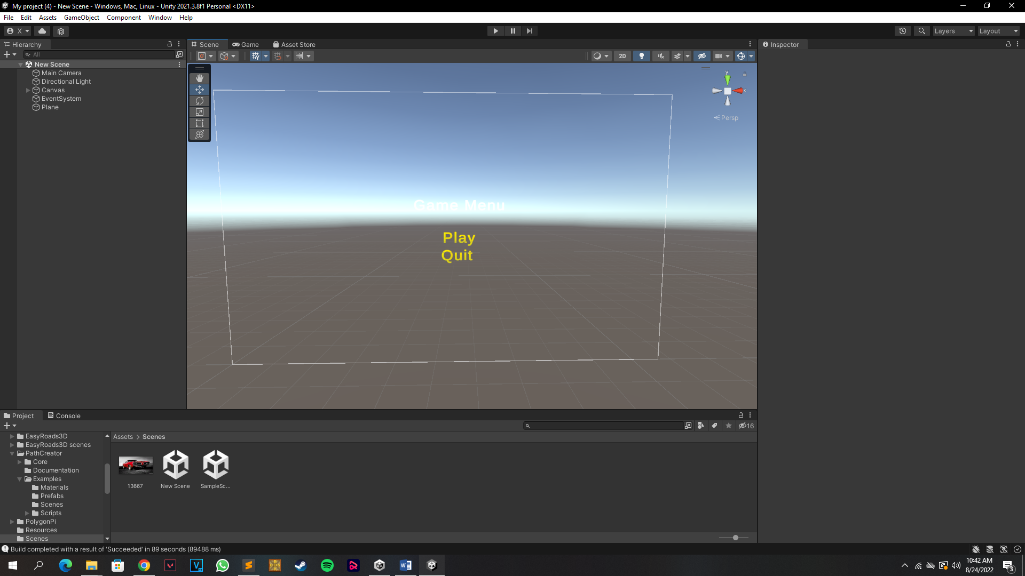**

**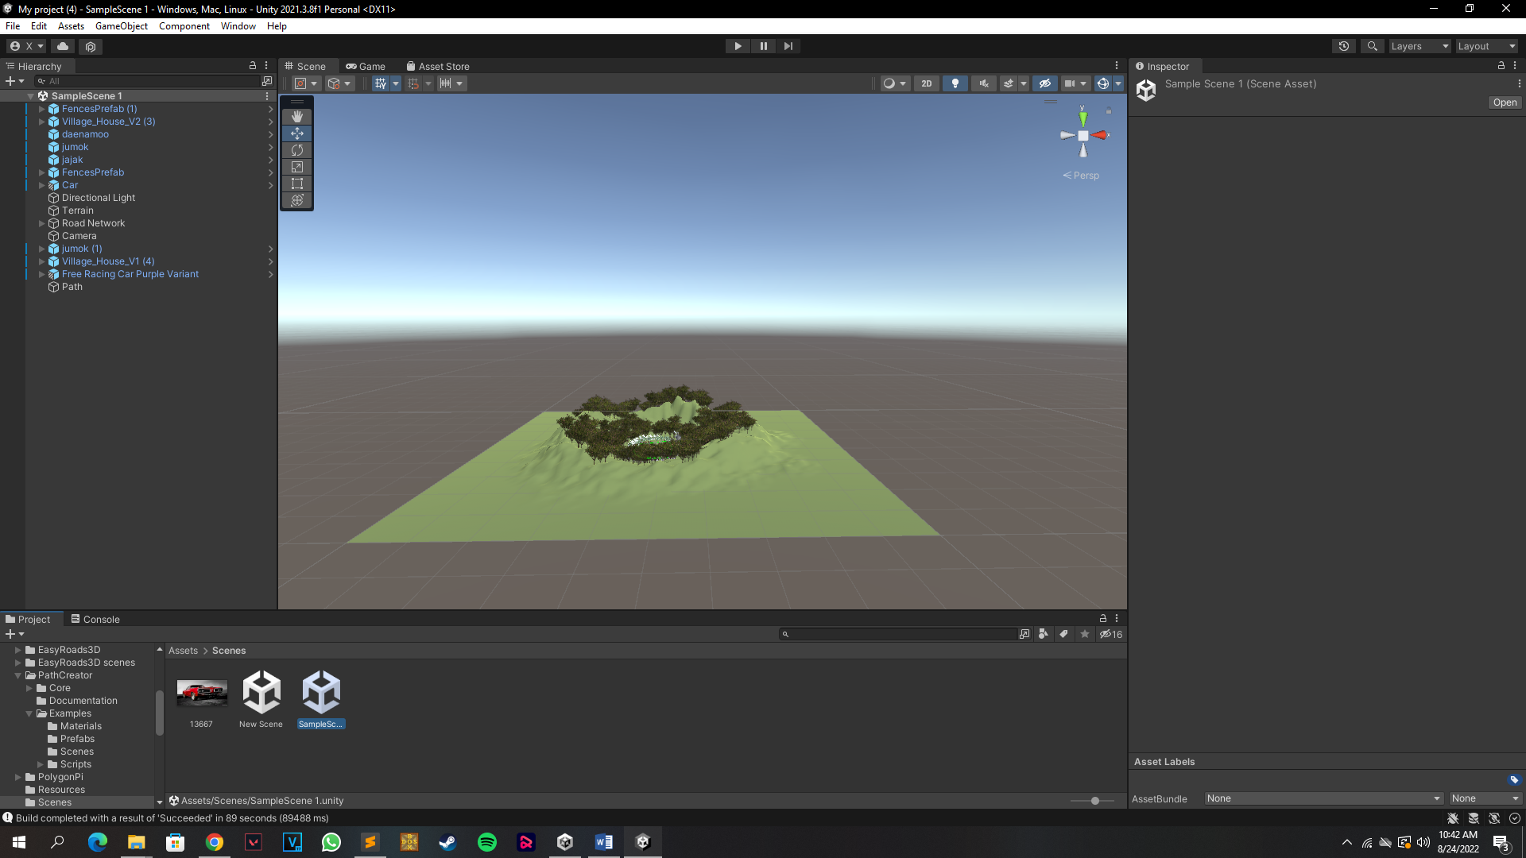**

**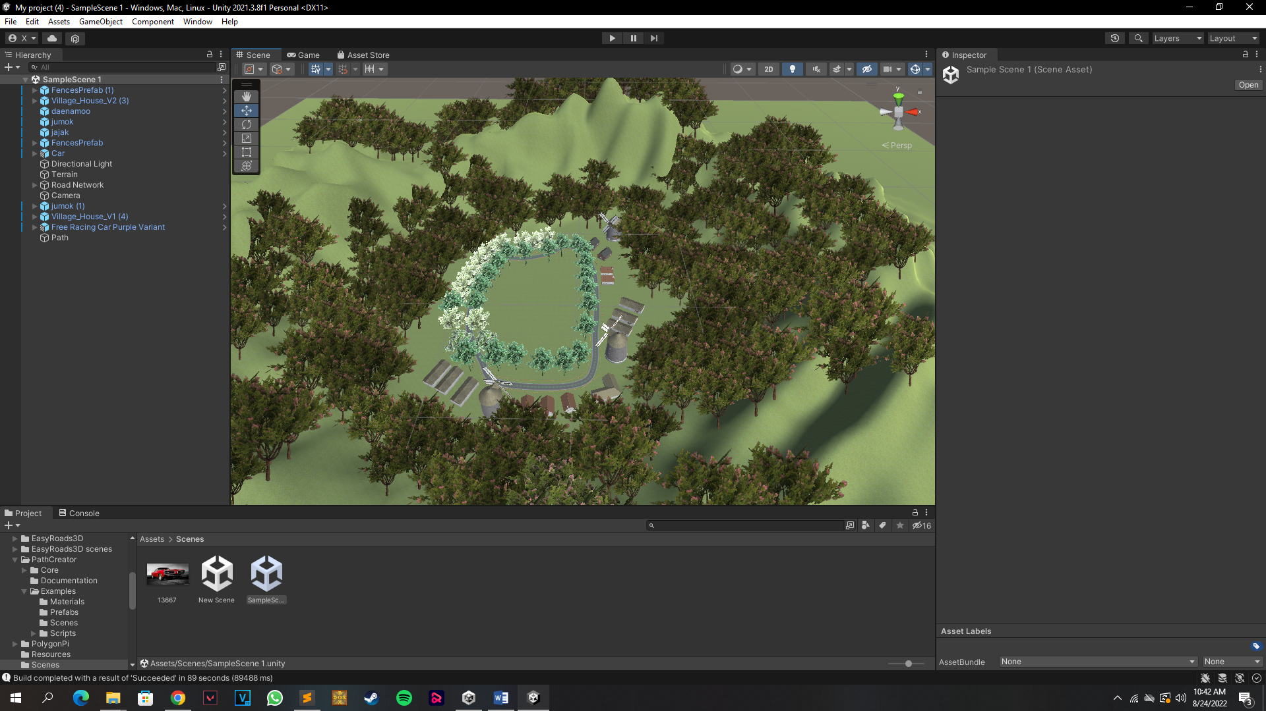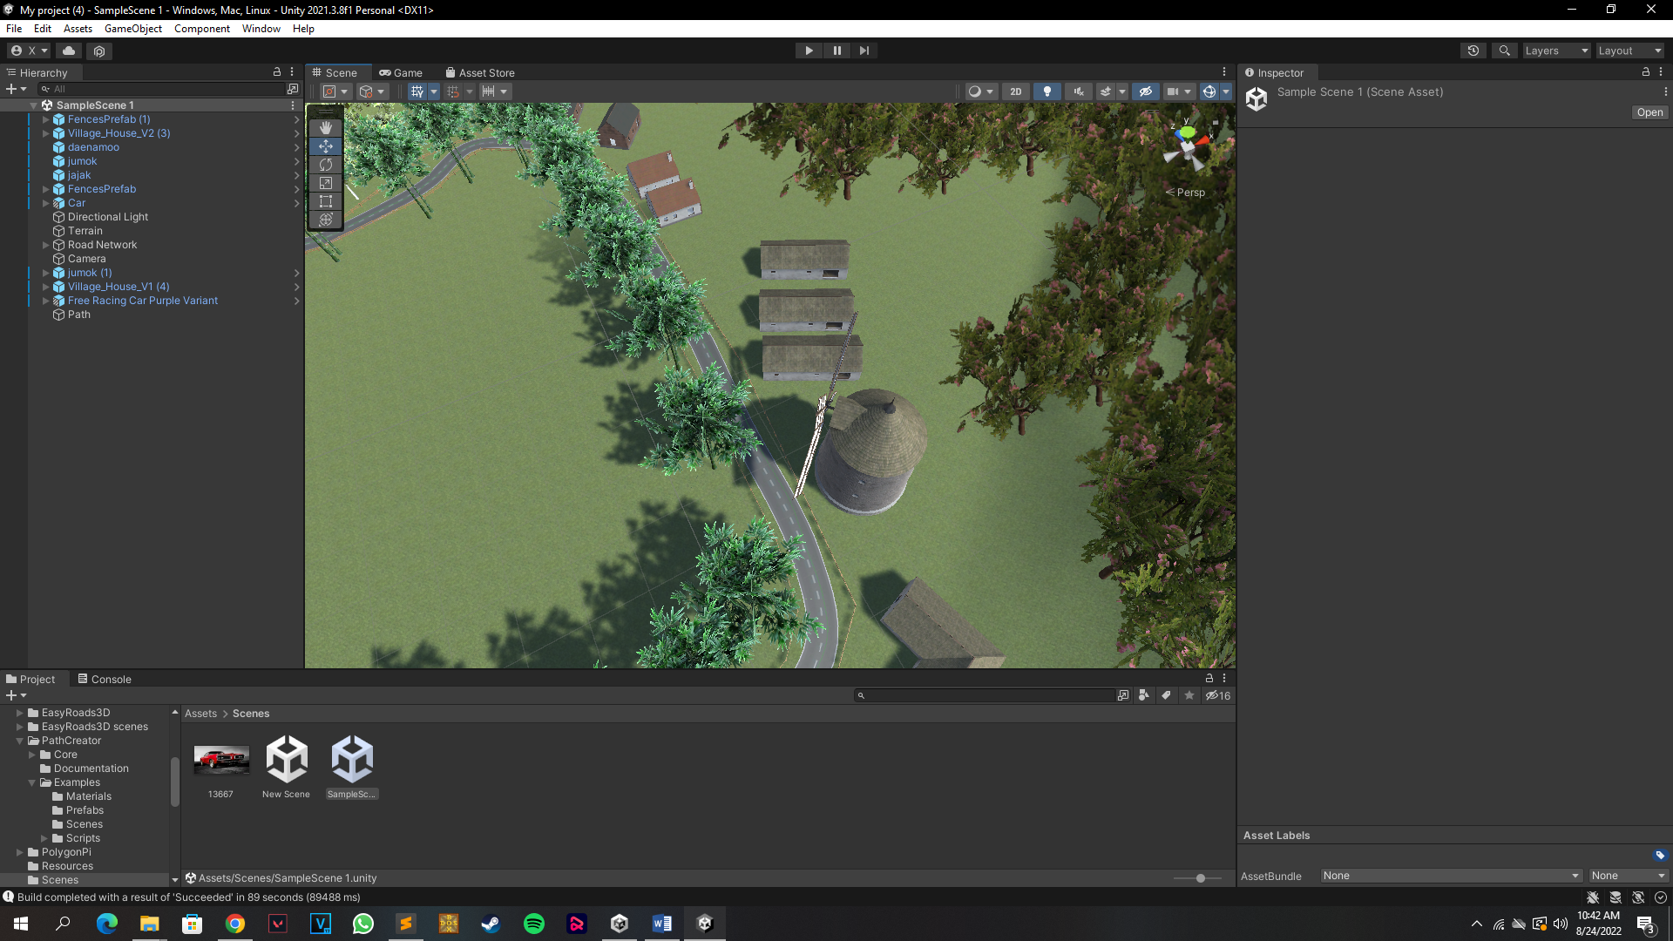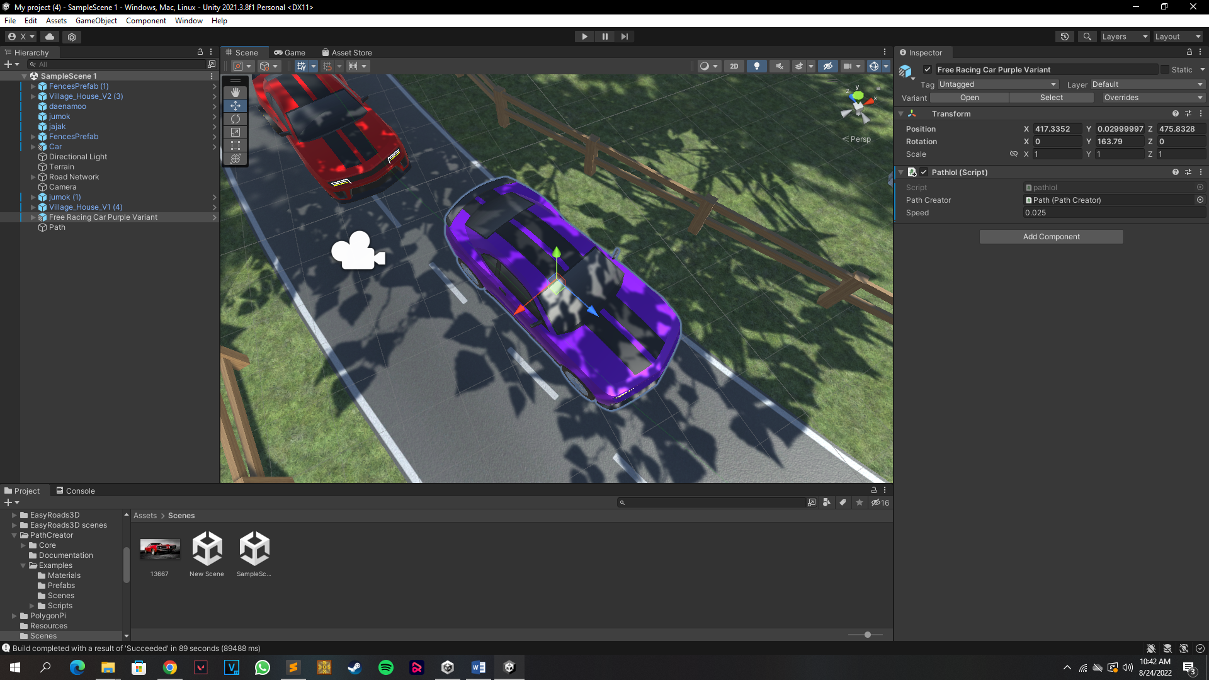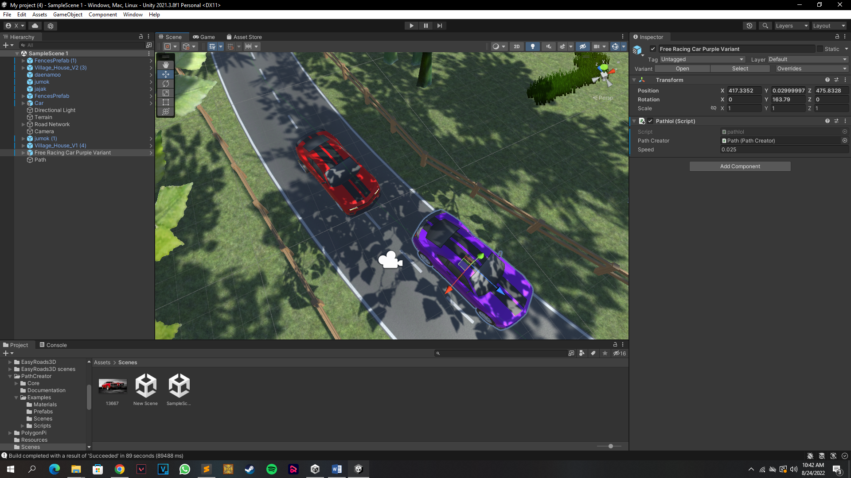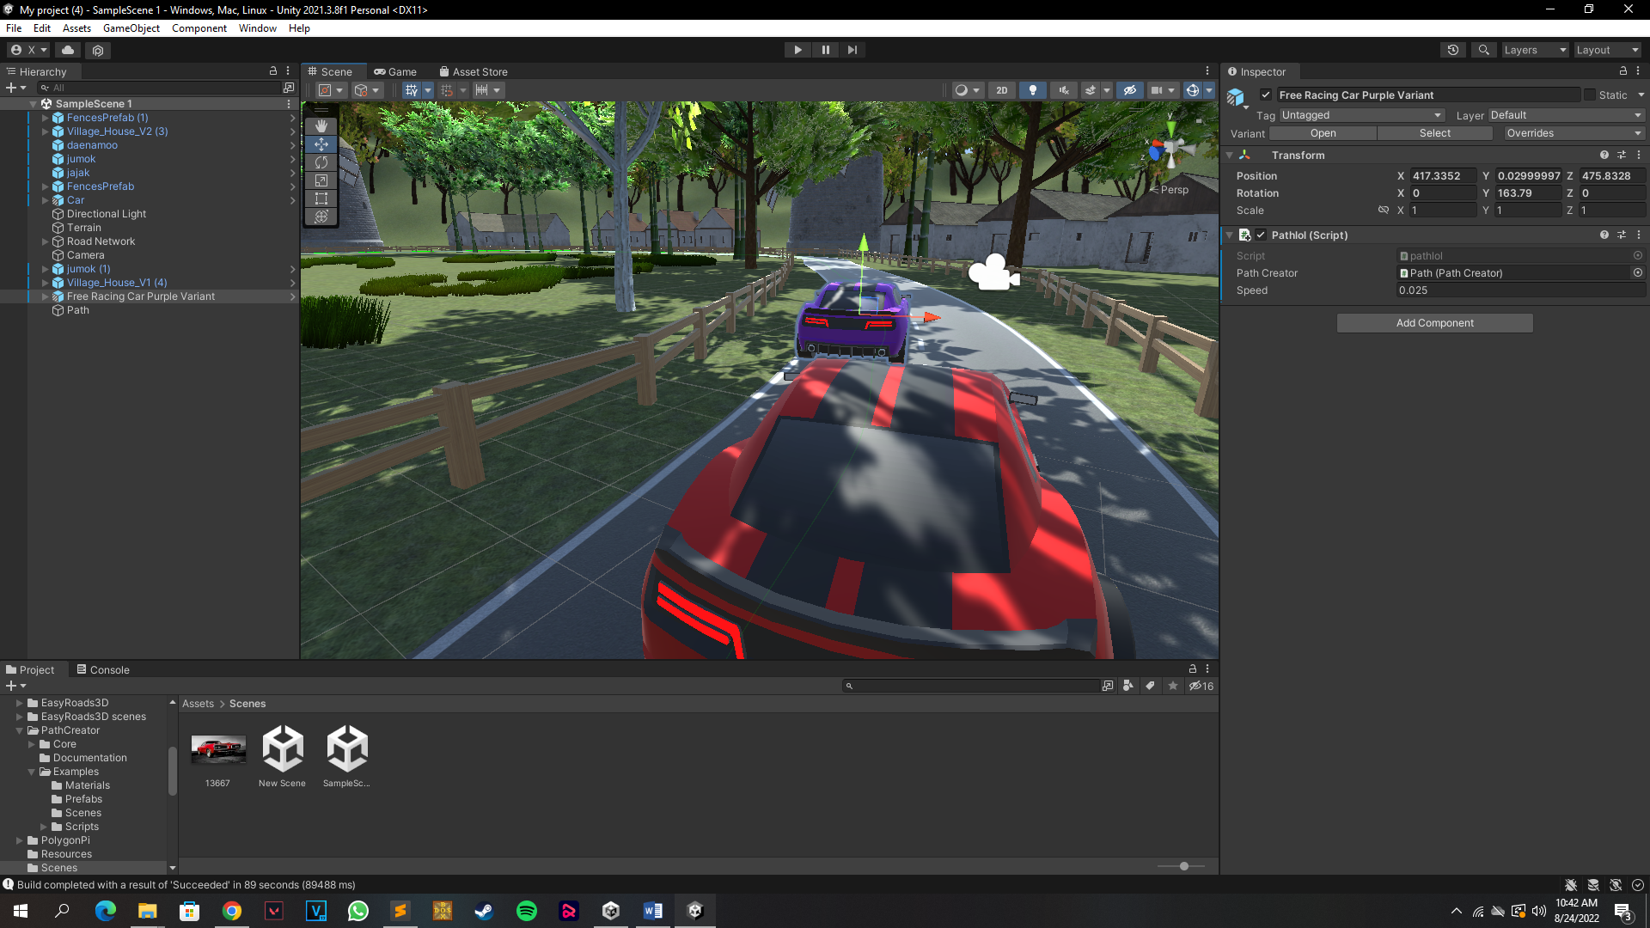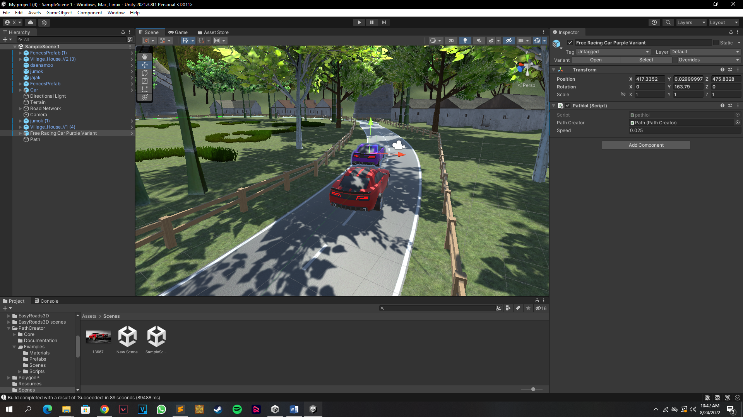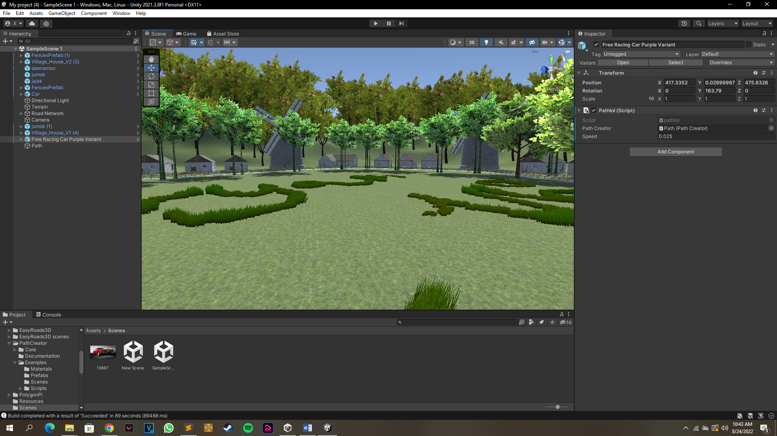**

**CONCLUSION**

RoadRash3 is created using unity engine and developed using C# language. It features movement and steering and also an AI based car to race with. This Project used some presets from the unit assets store which were modified to be used in the game.

This game will work on any new gen computer because of its small size. You need a keyboard to play the game and desktop to see the graphics.

This game doesn’t work with the android yet but futher builds will include the android version too.

**BIBLOGRAPHY**

[**https://en.wikipedia.org/wiki/Unity\_(game\_engine)**](https://en.wikipedia.org/wiki/Unity_(game_engine))

[**https://docs.unity3d.com/Manual/unity-architecture.html**](https://docs.unity3d.com/Manual/unity-architecture.html)

[**https://assetstore.unity.com/lists/heavy-equipment-150324?aid=1101l44FM&utm\_campaign=unity\_affiliate&utm\_medium=affiliate&utm\_source=partnerize-linkmaker**](https://assetstore.unity.com/lists/heavy-equipment-150324?aid=1101l44FM&utm_campaign=unity_affiliate&utm_medium=affiliate&utm_source=partnerize-linkmaker)

[**https://store.unity.com/**](https://store.unity.com/)